LoginScenario_TestForLoginWithNewlyRegisteredUser_Instance1_08-Jun-2017_12-47-17_PM_Register.png

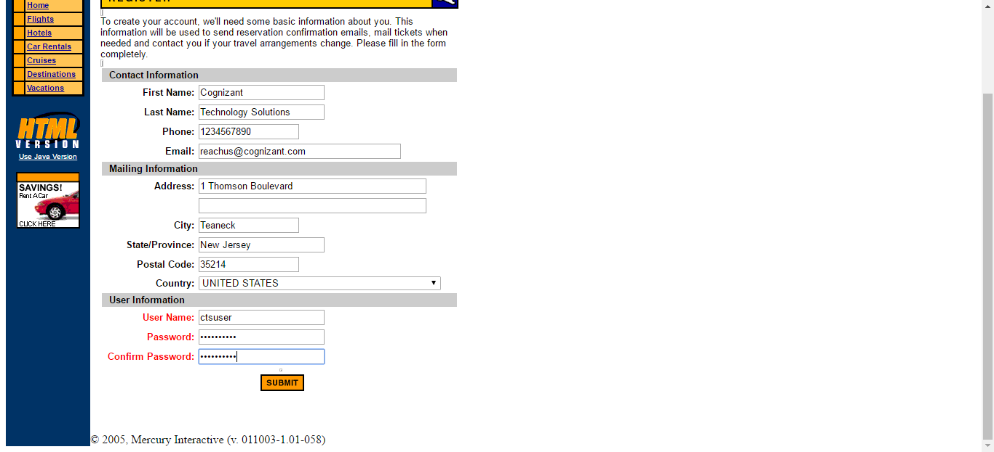

LoginScenario_TestForLoginWithNewlyRegisteredUser_Instance1_08-Jun-2017_12-47-19_PM_Verify_Registration.png

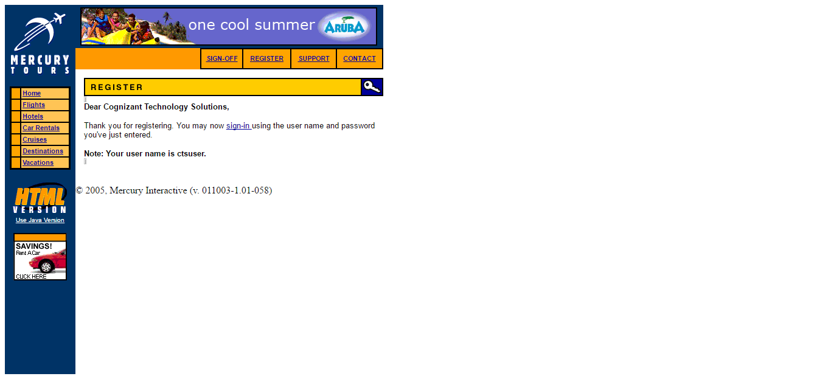

LoginScenario_TestForLoginWithNewlyRegisteredUser_Instance1_08-Jun-2017_12-47-21_PM_Enter_user_credentials.png

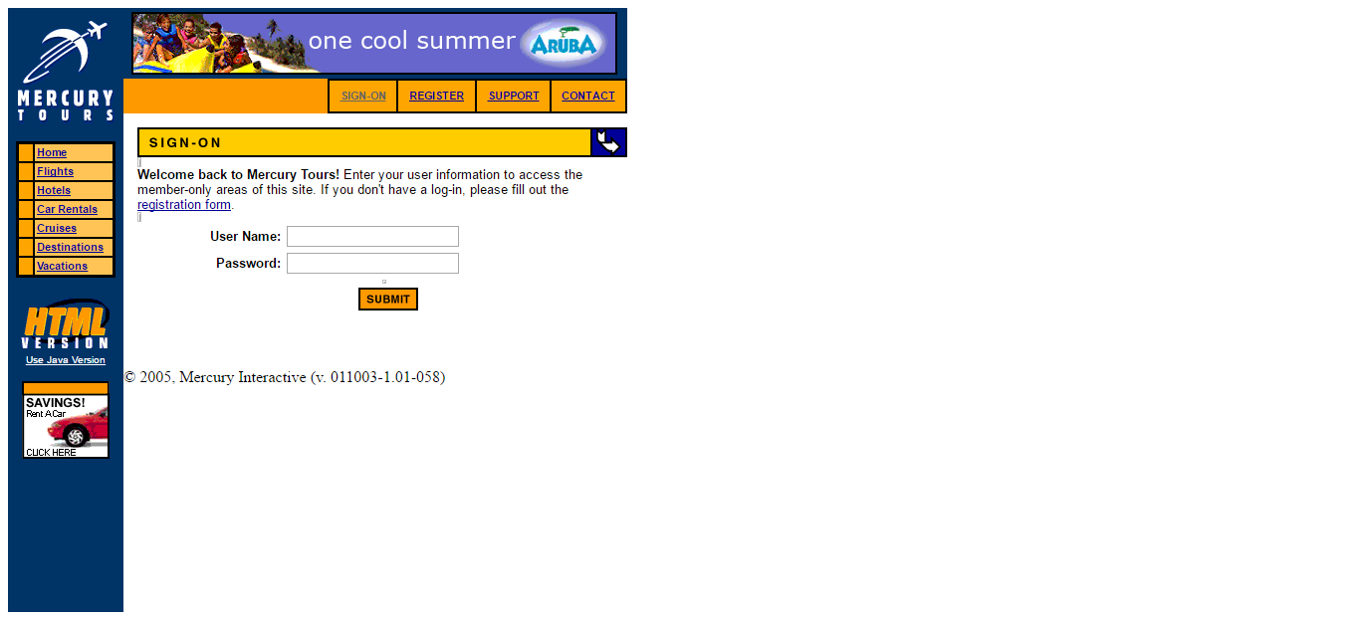

LoginScenario_TestForLoginWithNewlyRegisteredUser_Instance1_08-Jun-2017_12-47-21_PM_Login.png

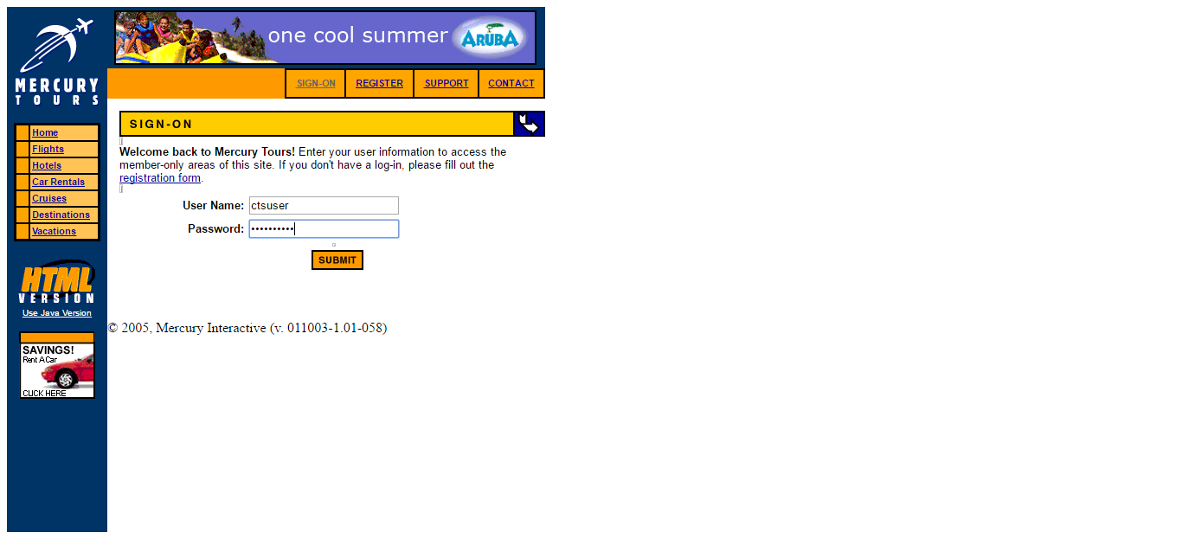

LoginScenario_TestForLoginWithNewlyRegisteredUser_Instance1_08-Jun-2017_12-47-26_PM_Verify_Login.png

